For the safety of everyone, please use hand sanitiser
before entering.
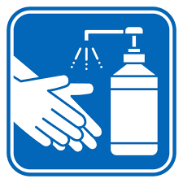
Do not enter if you feel unwell, or have a cough or you’re sneezing
Social Distancing

To protect our customers and staff at this time, we are actively managing the number of customers who can come into our premises at any one time.
Please make sure you stand
2m (6 feet) apart
using the marked lines on the floor.
When at the front wait behind the line until called forward.
Thank you for your understanding & co-operation.

CUSTOMER NOTICE
- While queuing please keep 2 metres between yourself & the
person in front of you.

- Please wear a face mask as required by law.

- We aim to serve you as soon as possible.

